**Terraform Assignment-1:**

1. Create an EC2 service in the default subnet in the Ohio region

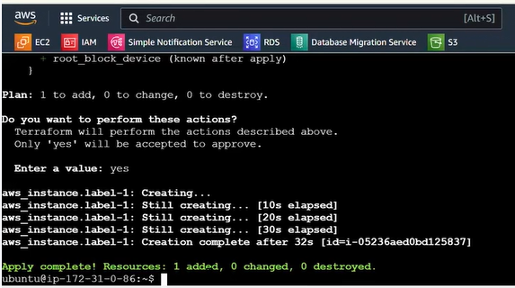



**Terraform Assignment-2:**

1. Destroy the previous deployment

Destroyed with the help of **destroyed terraform -y**

2. Create a new EC2 instance with an Elastic IP

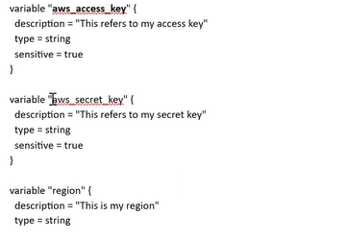

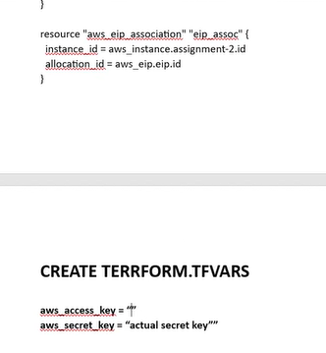

**Terraform Assignment-3:**  
1. Destroy the previous deployment

Destroyed with the help of **destroyed terraform -y**

2. Create 2 EC2 instances in Ohio and N.Virginia respectively

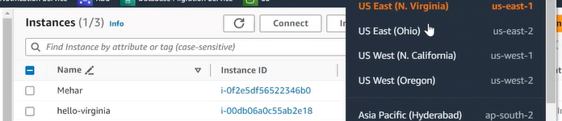

3. Rename Ohio’s instance to ‘hello-Ohio’ and Virginia’s instance to ‘hello-virginia’

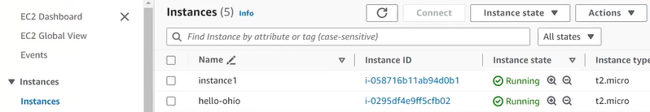

**Terraform Assignment-4:**  
1. Destroy the previous deployment



2. Create a VPC with the required components using Terraform

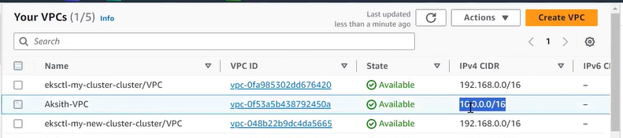

3. Deploy an EC2 instance inside the VPC

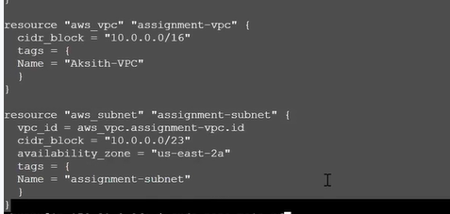

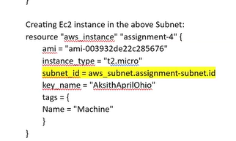

**Terraform Assignment-5:**  
1. Destroy the previous deployments



2. Create a script to install Apache2

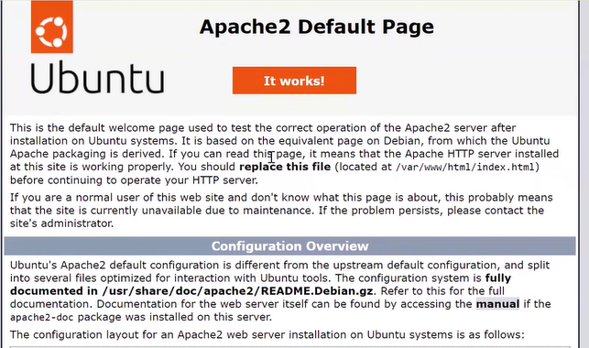

3. Run this script on a newly created EC2 instance

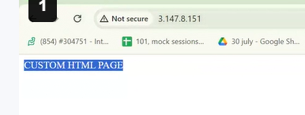

4. Print the IP address of the instance in a file on the local once deployed



**Project**

**Created the 3 instance master slave1, slave2, slave3**

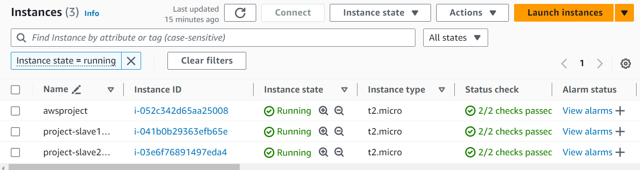

**Ansible is downloaded on 3 intance**

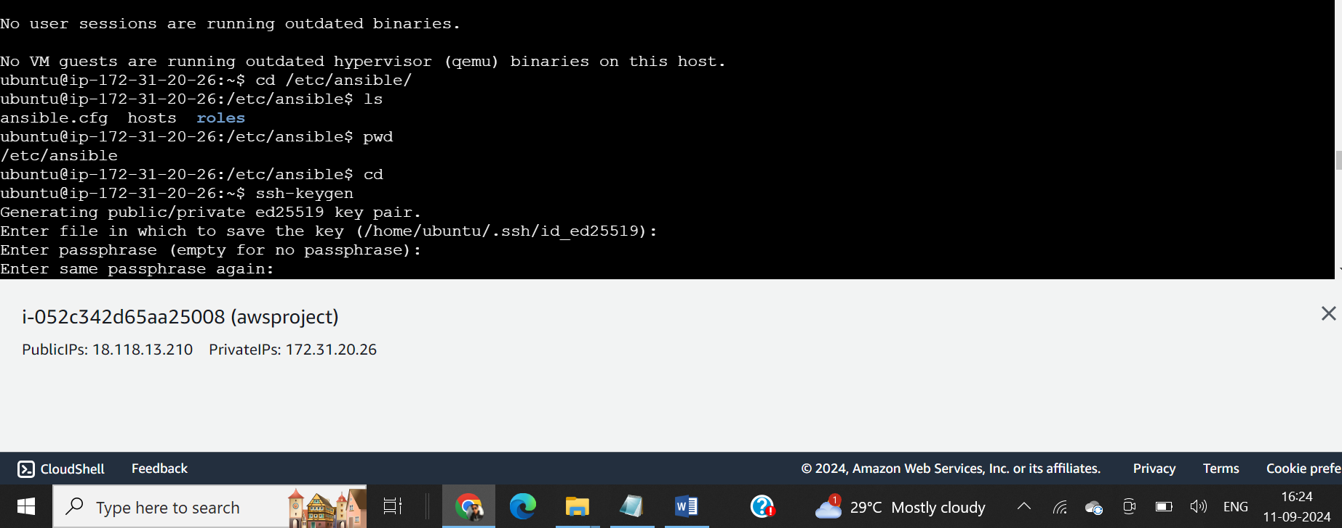

Configured jenkins using play book .yaml file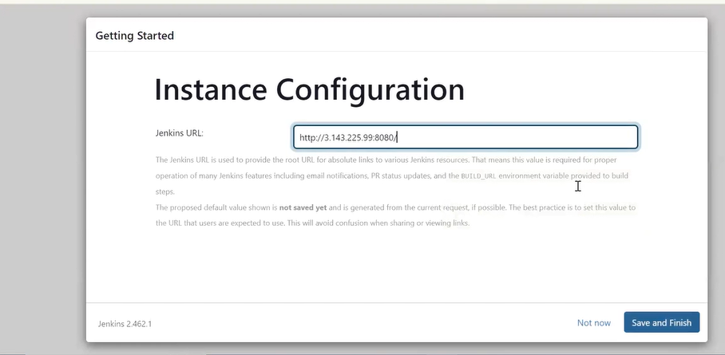

Creating node

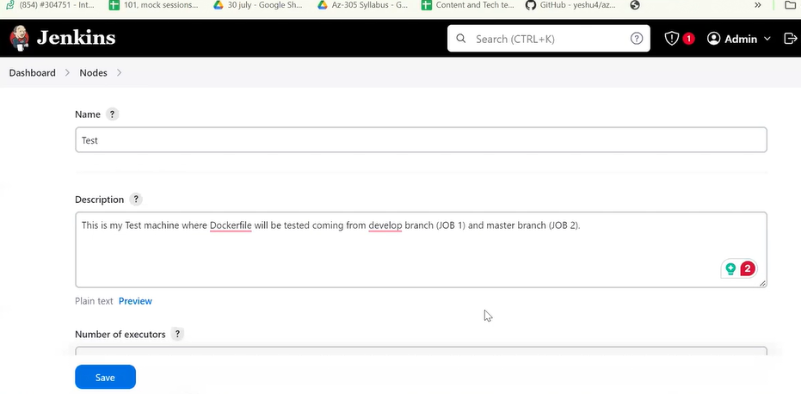

Node is created

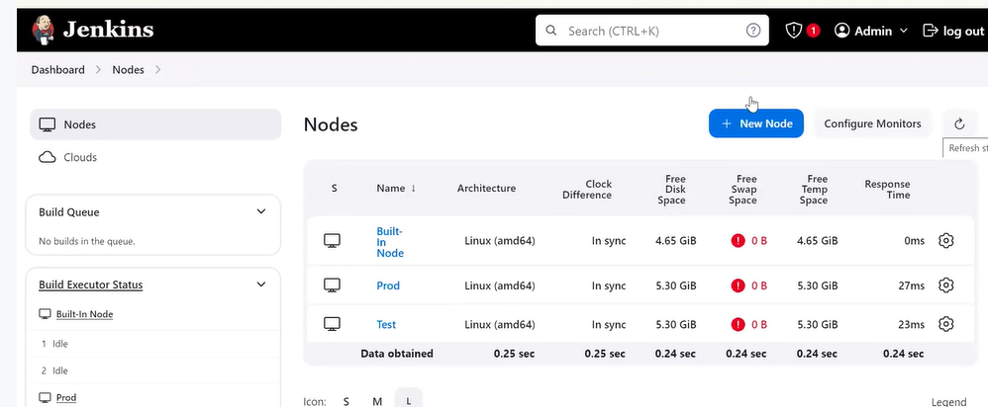

Created the 3 nodes in Jenkins from the git and created the branch and did the commit code is merged

